Rom Severin  RomSeverin@mail.tau.ac.il  Cell +972 52-222-1061  www.english.tau.ac.il/profile/romseverin  LinkedIn | 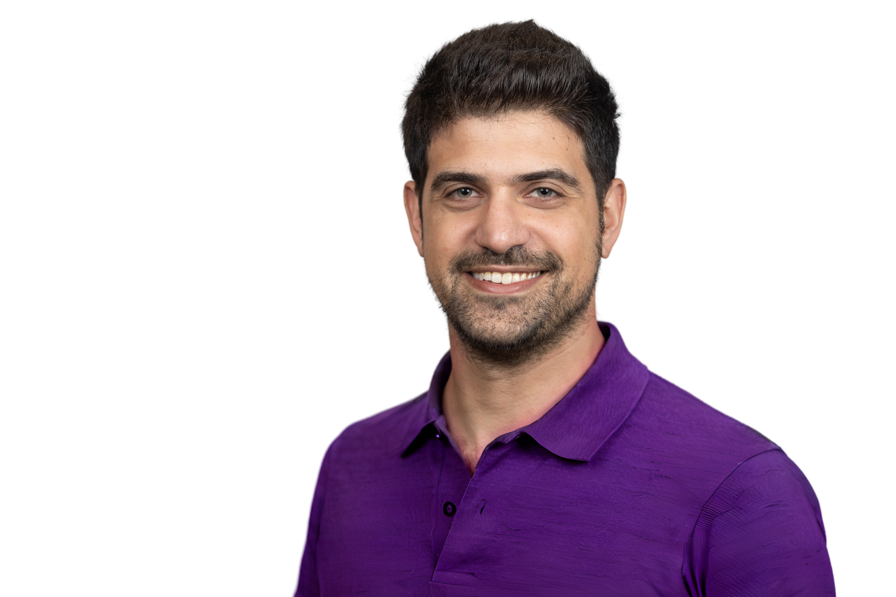  

Education | Tel-Aviv University
 |  | Ph.D. Business Economics, Coller Business School at Tel-Aviv University 2023 - Present
M.A. Economics, 2022

Advisor – Ayala Arad

 | The Academic College of Tel Aviv-Yaffo
 |  | B.A Economics, 2018

Fields | Experimental Economics, Behavioral Economics, Decision Theory, Microeconomic Theory

Fellowships &  Awards | Tel-Aviv University, Coller School of Management, Ph.D. scholarship 2023 – present  Tel-Aviv University, The Eitan Berglas School of Economics, MA scholarship for excellent academic achievements 2019 – 2022  Best Poster Award, Annual Research Seminar in Economics, MTA, 2022  MTA, Dean’s Honors List Excellence 2016, 2017  MTA, Chairman’s Honors List Excellence 2018
Teaching | Tel Aviv university – Berglas school of economics  Undergraduate Introduction to Microeconomics, teaching assistant for Galya Ofer 2018 - present  Undergraduate Price Theory B (Advanced Microeconomics), teaching assistant for Hadar Binsky and Zvi Neeman 2018 - 2021  Tel Aviv university – Coller school of management  Undergraduate Behavioral Economics, teaching assistant for Ayala Arad 2023 - Present  Undergraduate Business Economics, teaching assistant for Ayala Arad 2024  Graduate Finance for Mangers, teaching assistant Evgeny Lyandres 2020 - 2024  Graduate Strategy for Managers, teaching assistant for Yossi Spiegel 2019 - 2023  Graduate Competitive Strategy, teaching assistant for Yossi Spiegel 2019 - 2023  Reichman university – MBA  Graduate Experimental Economics, teaching assistant for Tali Regev 2018 - 2020  Graduate Finance for big data MBA, teaching assistant for Ari Achiaz 2019 - 2020  The Academic College of Tel Aviv-Yaffo – Economics  Undergraduate Introduction to Finance teaching, assistant for Shlomit Zuta 2021 - 2022  Undergraduate Introduction to Microeconomics, teaching assistant for Shirit Ktav Hertz 2019 - 2021  Undergraduate Introduction to Macroeconomics, teaching assistant for Chemi Gotlibovski 2020  Ariel University – Healthcare Administration  Graduate Economics in Healthcare teaching, assistant for Gile Fire 2020 - 2021
Research positions | Research Assistant for Ayala Arad 2021- present  Researcher in the Safra Research Institute for Banking and Financial Intermediation 2023 - present  Research Assistant for Rachel Kalifa 2019-2023

Papers in Progress | "Decision-making procedures in general vs. concrete problems: Using AI for elicitation"  Consider an investor who instructs her broker to follow her desired decision rule, taking into account various market conditions. Would the nature of this decision rule differ had she instructed the broker regarding specific investment decisions on a case-by-case basis? How does a general rule-based bonus system devised by a manager differ from his case-by-case decisions regarding employees’ bonuses in the absence of such a system? Does setting a general strategy for appliance purchases influence consumers’ specific purchase decisions?  This research attempts to answer such questions- it spans various decision-making environments and experimentally examines whether and how decision rules for general problems (i.e., problems that may occur on various occasions with different parameters) and their induced choices differ from the decisions individuals make when facing specific problems. To elicit decision rules for general problems, we use a novel experimental design whereby participants face an abstract decision problem, with unknown parameters, and describe their desired decision rule to a bot, which in turn implements this rule across a set of concrete problems. In a concrete treatment, participants make manual case-by-case choices, and conduct a post-choices replication task whereby they are incentivized to describe the decision procedure they have followed to a bot. Additional treatments allow examining various degrees of abstraction and concreteness. We suggest construal level as a key factor for driving the differences between general and concrete decision-making, and examine the role of individuals’ (in)ability to imagine all possible parameter values of specific problems when setting a general decision rule.  People encounter general decision problems in various circumstances, such as when providing guidelines in delegation and when zooming out to consider a broader perspective before making a concrete choice. The proposed experiments shall offer insights into how individuals address general decision problems, and how it differs from making decisions in concrete problems. By identifying the decision procedures participants use when facing general problems, this project aims to provide the foundations for theoretical models that involve such problems.
Working Papers | "The Perception of Mistakes Driven by Cognitive Biases: An Experimental Study"  This thesis presents findings from an online experiment aimed at evaluating individuals' attitudes towards their own cognitive biases that lead to objective mistakes. In a number of incentivized decision problems, a participant in the experiment might make a mistake and choose a dominated lottery (FOSD lottery), which is likely to result from a particular heuristic or cognitive bias. In this case, she is then confronted with her error under one of two treatments: a confrontation with an explanation only regarding the mistake or one with the addition of the supposed mechanism (bias). Following this explanation, her comfort level with her choice is measured. A bias that acted as a mechanism for the observed error could be considered advantageous (ie, useful given alternative costs) or disadvantageous (ie, mostly harmful) in other decision-making scenarios encountered during one's lifetime. Consequently, the perception of cognitive biases is subjective and may vary among decision makers, who may emphasize either the positive or negative aspects of such biases. The proposed methodology allows to determine whether these biases are perceived as useful rules of thumb, despite leading to a dominated lottery choice in that particular context, or unfavorable.  Results revealed significant differences between the two treatments and across five different decision problems. Interestingly, the results showed that in only 60% of the cases, the participants felt uneasy about their mistakes. In the remaining instances, the participants demonstrated either indifference or a sense of comfort with their choice of a dominated lottery. The net effect of providing information on the cognitive biases that presumably lead to the mistakes, measured as the difference between treatments, revealed a negative perception of the mechanism behind the error in one problem, contentment with the mechanism for another, and no significant effect for the remaining biases.

Seminars,  Summer Schools  and Conferences | Presentation, Economic Science Association World Meeting, Renmin University of China, 2025  Presentation, Multidisciplinary Research in Consumer Behavior Workshop, Solomon Lew Center, Tel Aviv University 2025  Poster presentation at the 1st Summer School in Experimental and Behavioral Economics, by the European Economic Review, University of Crete 2024  Poster presentation at the 10th Behavioral Game Theory Workshop, University of East Anglia 2024  Poster presentation at the 1st Annual Conference of the Network of the Behavioral and Experimental Economists based in the UK 2024  Participation in ECEE summer school in Experimental Economics, TalTech University 2023  Poster presentation at the 7th Solomon Lew Conference on Behavioral Economics, Tel-Aviv University 2023  Poster presentation at the Annual Research Seminar in Economics, MTA 2022 (Awarded Best Poster)  Presentation at the IN2IT WP5 (Development and exploitation of academy-industry/community cooperation) Summary Meeting, Kingston University London 2018 (Received Certificate of Excellence)

Academic Service | Reviewer for the Journal of Behavioral and Experimental Economics  Reviewer for The Behavioral Economics Guide  Organized the Fourth Israel Behavioral Finance Conference, MTA 2022

Research Grants | The Solomon Lew Center for Consumer Behavior Research Grant 2024
Volunteer | English Tutor at Out for Change- an organization supporting formerly ultra-Orthodox men and women, 2025–Present.  Volunteer as a financial mentor for university students receiving stipends, as part of an initiative by the university’s graduate organization, 2024–Present.  Volunteer at Sheba Hospital's Innovation Center and Patient Experience Department, providing immersive, meditative VR experiences to aid in the relaxation and recovery of soldiers 2023 – 2024  Teaching micro-economics as part of Bar Ilan's "YOEL program" (Ethiopians descendent to quality academia). The YOEL Program strives to enable young Ethiopian Israelis to participate in quality academic studies, aiming for suitable employment and social mobility 2022 - 2023  Teaching mathematics and probabilities using Backgammon at the GIL School for autistic children 2018 - 2019
Other  Professional  experience | Student Experience Coordinator, Coller School of Management, 2023 - Present  Economist at Precise, managing 2 clients, "V5 Architecture" and "Avner I Engineering", 2017 – 2018  Desk Analyst Manager, Dun and Bradstreet 2016 - 2017
  Hobbies | Trumpet Playing  Indoor Bouldering  Does researching decision-making actually help me make better decisions?

